📚Library Management System Project Report

Fatima Jinnah Women University
Bachelor of Computer Science (BSCS)
Semester: 2

Submitted to: Adeel Khalid

Name:
Malaika Zahoor (FA24B1-CS-072)

Introduction
Objective:
To design and implement a Library Management System that maintains data of books, members, authors, employees, admins, and their transactions.

Tools Used:
- Oracle SQL Developer
- Java Swing (for GUI)
- JDBC (Java Database Connectivity)
- ER Modeling (using standard notation)

2. ER diagram:

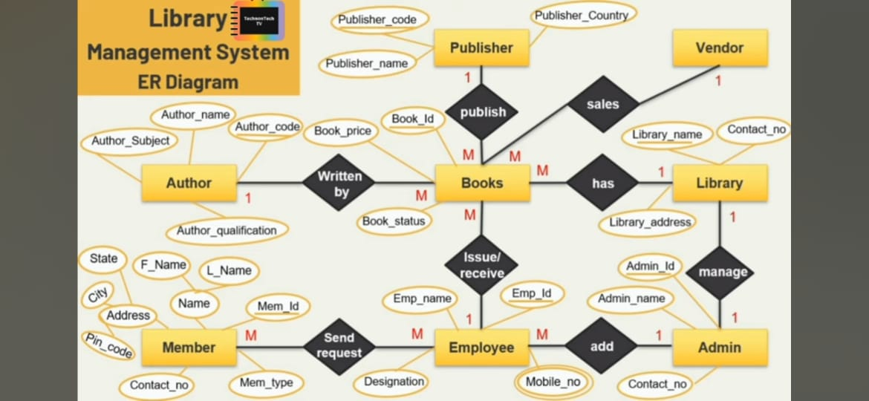

📚Library Management System ER Diagram:
1. Entities and Their Attributes:
The ER Diagram identifies several key entities, each representing a distinct object or concept within the library system.
Publisher: Represents organizations that publish books.
Vendor: Represents entities from whom libraries acquire books (e.g., distributors, bookstores).
Author: Represents individuals who write books.
Books: Represents individual book titles in the library.
Library: Represents a specific library branch or institution.
Name: Full name of the member (composed of F_Name and L_Name).
Mem_type: Type of membership (e.g., "student," "faculty," "general").
Employee: Represents staff members working in the library.
Emp_name: Name of the employee.
Admin: Represents administrative personnel with elevated privileges in the system.
Admin_id (Primary Key): Unique identifier for the admin.
Admin_name: Name of the admin.
Contact_no: Contact number of the admin.
2. Relationships and Cardinality:
Relationships, shown by diamonds, connect entities and represent how they interact. Cardinality, indicated by numbers (1) and letters (M for many), specifies the number of instances of one entity related to instances of another. For example, a Publisher can publish many Books (1 to M). Conversely, many Books are written by many Authors (M to M), indicating a many-to-many relationship where a book can have multiple authors and an author can write multiple books. An Employee can issue/receive many Books (1 to M), while a Book is issued/received by one Employee. A Member can send requests to many Employees (M to M). Lastly, a single Admin can manage exactly one Library (1 to 1).

3. Tables created in SQL developer:
Publisher: Stores publisher details (Publisher_code PK).
Vendor: Stores vendor information (Vendor PK).
Books: Stores book details (Book_Id PK, Publisher_code FK).
Library: Stores library details (Library_name PK).
Author: Stores author details (Author_code PK).
Member: Stores member details (Mem_Id PK).
Employee: Stores employee details (Emp_Id PK).
Admin: Stores administrator details (Admin_Id PK).
4. Java connectivity summary
Java connectivity, primarily achieved through JDBC (Java Database Connectivity), provides a standard API for Java applications to interact with various relational databases. It involves loading a specific database driver, typically using Class.forName(), which registers the driver with the DriverManager. Subsequently, a Connection object is established using DriverManager.getConnection(), specifying the database URL, username, and password. This Connection acts as a session with the database, enabling the creation of Statement or PreparedStatement objects. These objects are then used to execute SQL queries (like SELECT, INSERT, UPDATE, DELETE) against the database. ResultSet objects are used to retrieve and process data returned by SELECT queries. Proper resource management is crucial, involving the closing of ResultSet, Statement, and Connection objects in a finally block to prevent resource leaks and ensure efficient application performance. This robust framework allows Java applications to perform data persistence and retrieve information from backend databases seamlessly.
✨Conclusion and References
Conclusion:
In conclusion, the synergy between a well-designed ER Diagram and robust Java connectivity forms the bedrock of a powerful and maintainable database-driven application like the Library Management System. The ER Diagram, as a conceptual blueprint, meticulously defines the entities—such as Publisher, Books, Author, Member, Employee, Admin, Vendor, and Library—along with their attributes and the intricate relationships between them. This visual representation directly translates into the structured tables created in SQL Developer, where each entity becomes a table, and the attributes become columns. Crucially, the many-to-many relationships are elegantly resolved through dedicated junction tables (e.g., Publish, Written_By, Issue_Receive), ensuring data integrity and preventing redundancy.
Once the database schema is established, Java connectivity, powered by JDBC, bridges the application logic to this persistent data store. The process involves dynamically loading the Oracle JDBC driver and then establishing a Connection using the database URL and credentials. This Connection object is fundamental, providing the necessary channel for Java to execute SQL commands. Through Statement or PreparedStatement objects, the Java application can perform all CRUD (Create, Read, Update, Delete) operations on the meticulously designed tables. For instance, an "Add Book" form would use an INSERT query to populate the Books table, while a "Login" form would execute a SELECT query against user tables. Ultimately, the ER Diagram provides the structured framework, and Java connectivity provides the dynamic means to interact with and manage the data within that framework, resulting in a cohesive and functional system.
References:
- Oracle SQL Developer Docs
- Java JDBC Docs
- ER Diagram: TeacherTech TV
- Course Notes and Lab Sessions

